**SMART WEATHER PROJECT**

**Submitted to: Submitted by:**

**Simlpilearn Rajachandra Naru**

**CONTENTS**

1. **INTRODUCTION...............................................3-4**
2. **EPICS................................................................4-6**
3. **USER STORIES...................................................7-14**
4. **BACKLOG.........................................................15-16**
5. **SPRINT............................................................17-18**
6. **REPORTS........................................................ 19-20**

**1.INTRODUCTION:**

The purpose of the project is to apply the concepts learned in the Agile Scrum Master course by analysing a hypothetical organization.

Participants are encouraged to apply the techniques learned during the program but can also be creative in applying other techniques from other sources.

The steps may not always be carried out in the same sequence in real life. Participants may iterate through steps, as they may uncover ideas as they proceed from one step to the next.

**Project Description**

GTM systems is a large IT company with offices all around the world. The company delivers software products and services to corporate clients. One of the reasons for its enduring success and consistent performance over the years is the ability to leverage technology and find innovative applications for it.

**Smart Weather**

With climate change increasing the unpredictability of local weather conditions, there has been great demand for technology that can provide reliable weather information. Weather conditions impact several organizations and businesses – ranging from agriculture, outdoor event management, hospitality, travel and tourism, and healthcare.

While GTM has no expertise in meteorology, it proposes to aggregate weather data from multiple providers and use analytics to correlate it with meaningful conclusions for businesses.

Example use cases could be generating forecasts based on local weather conditions around:

1. Consumption of hot versus cold beverages depending on cold, sunny, or rainy weather
2. Number of visitors to a tourist site or an open-air entertainment event
3. Likelihood of seasonal illnesses such as flu in particular locations

The main system will comprise a web portal and a set of “apps” available on the popular mobile operating systems. Apart from this, clients can ask for specific services or apps based on the insights that the analytics can generate.

**2. EPICS:**

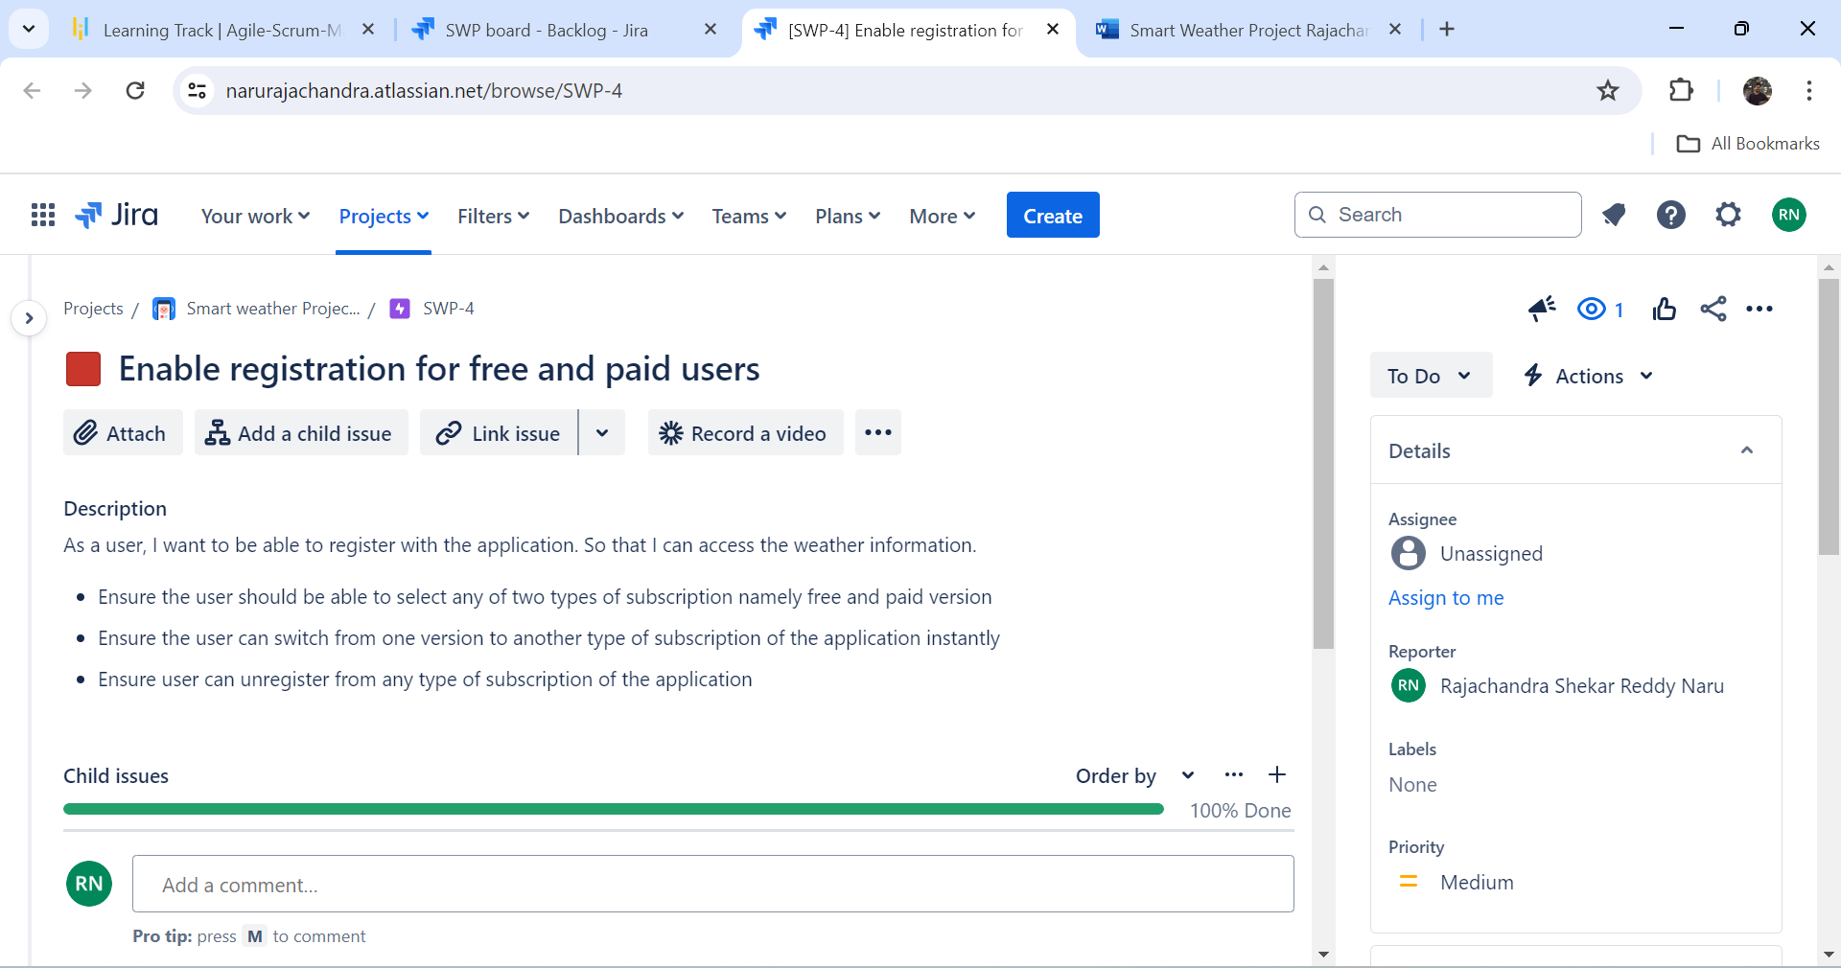

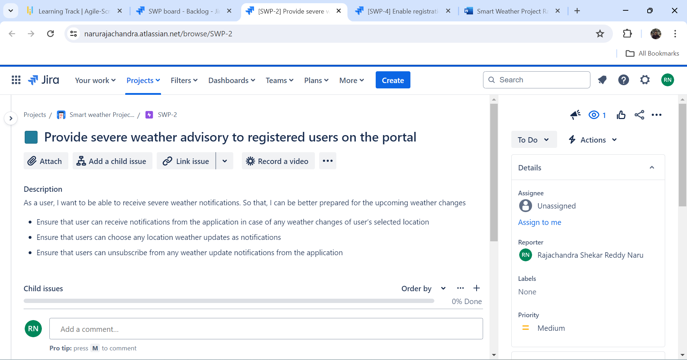

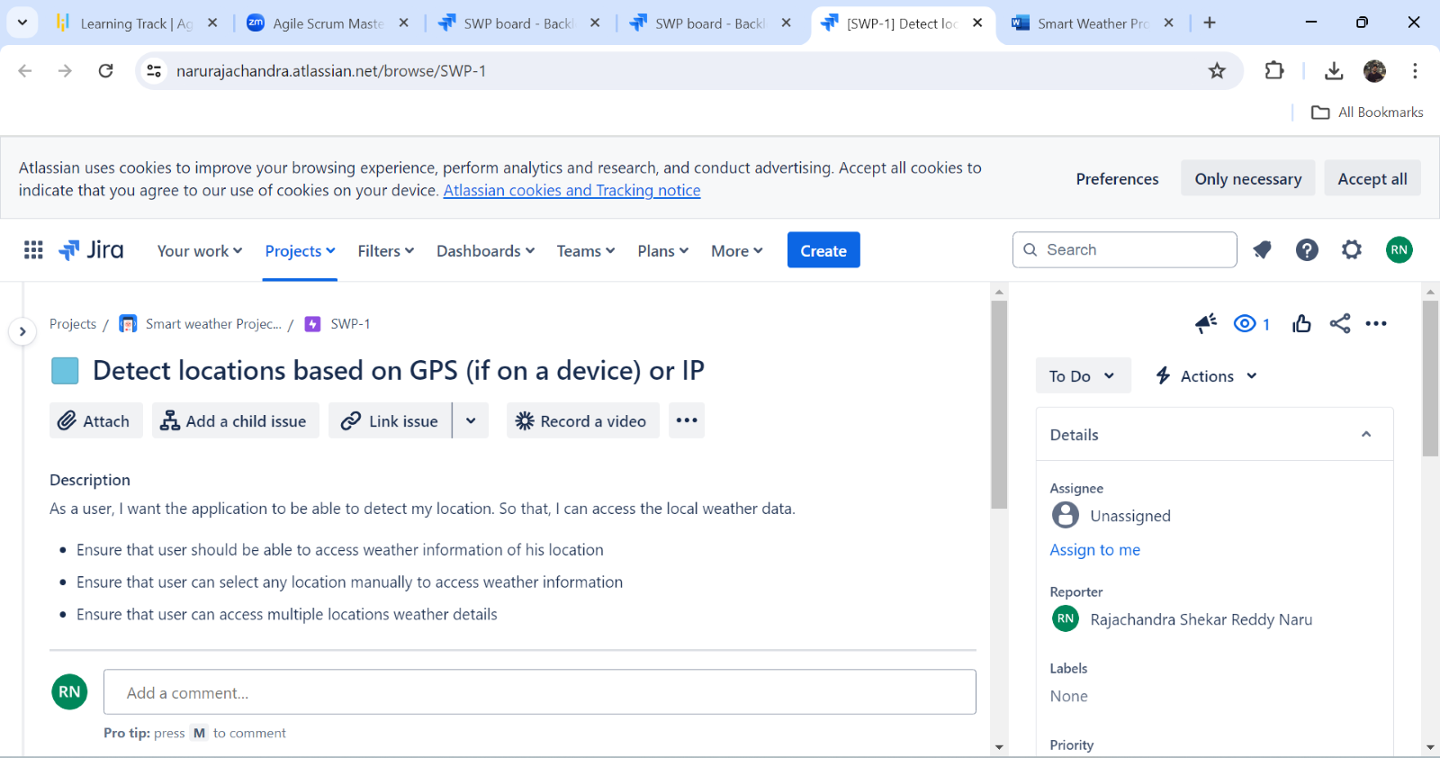  
  
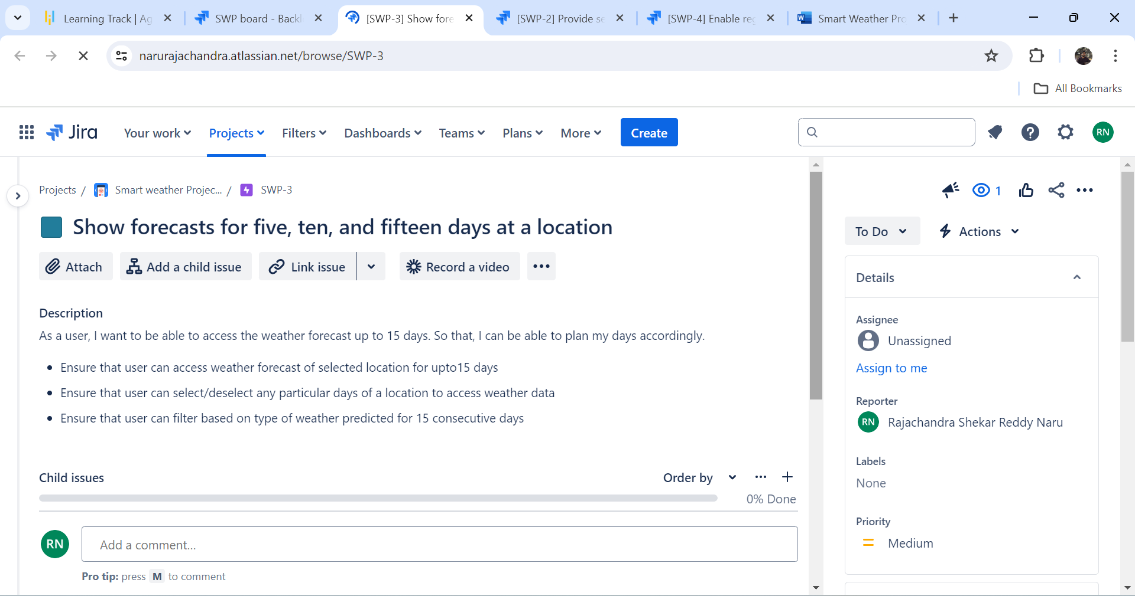

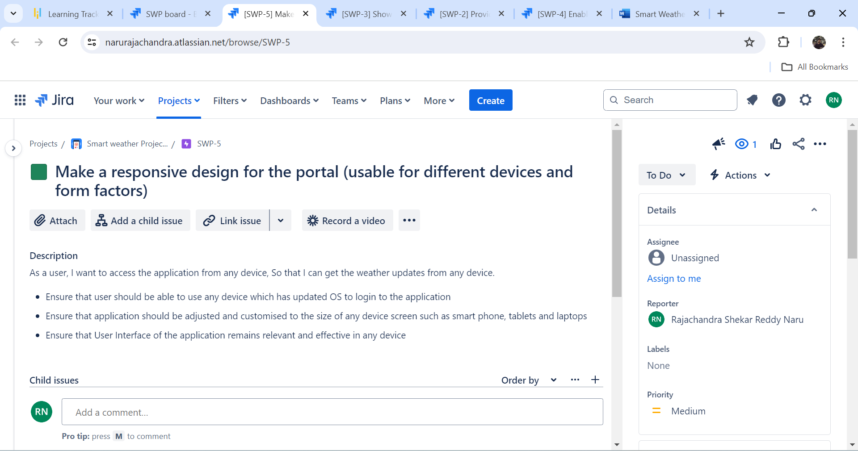

**3. USER STORIES:**

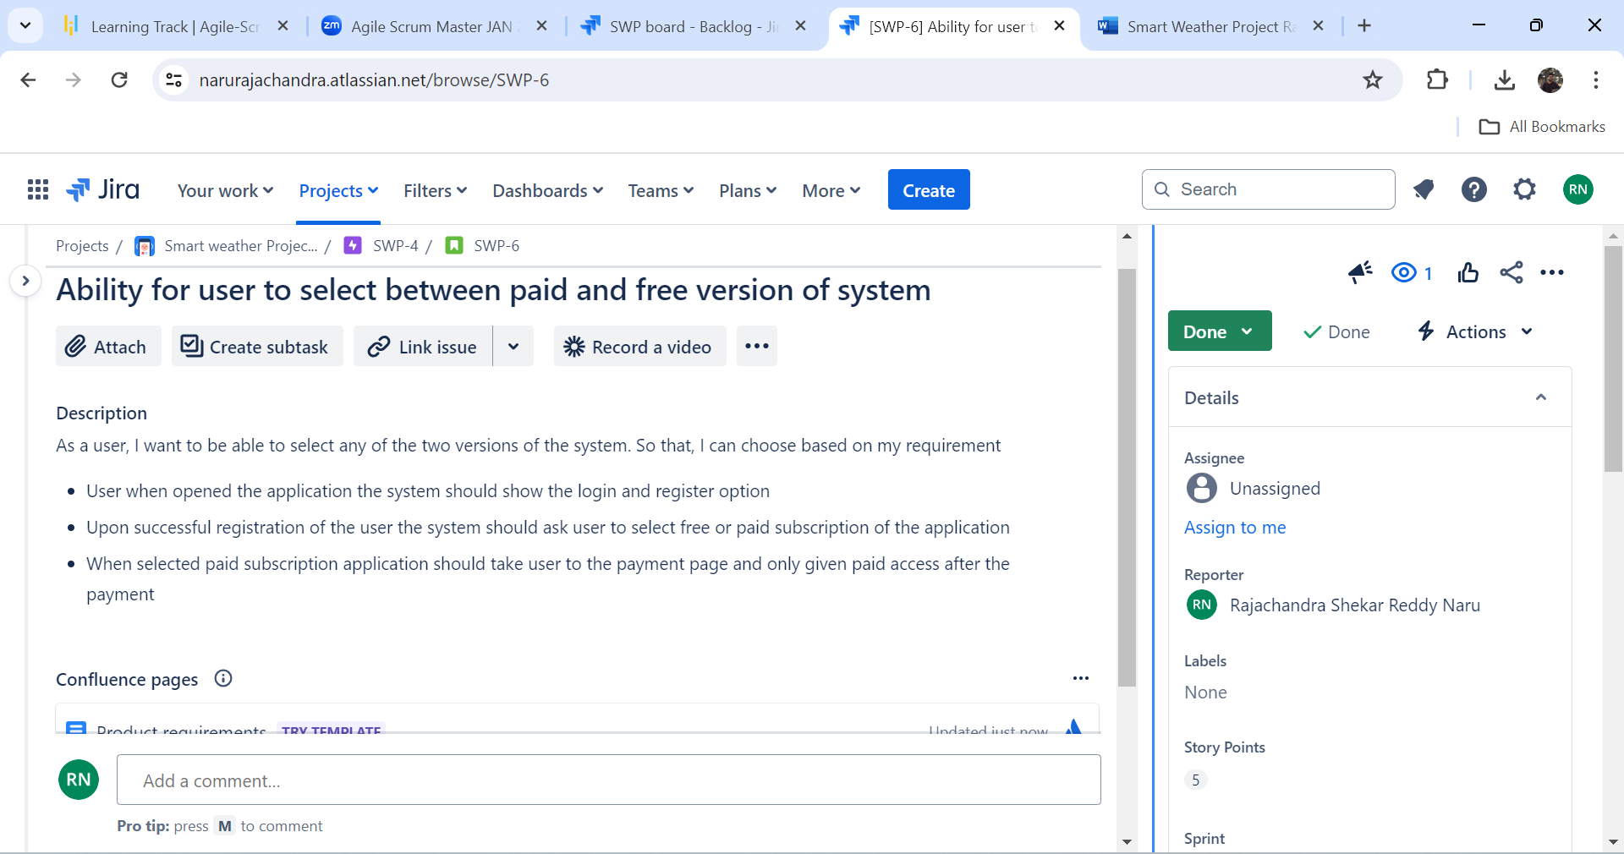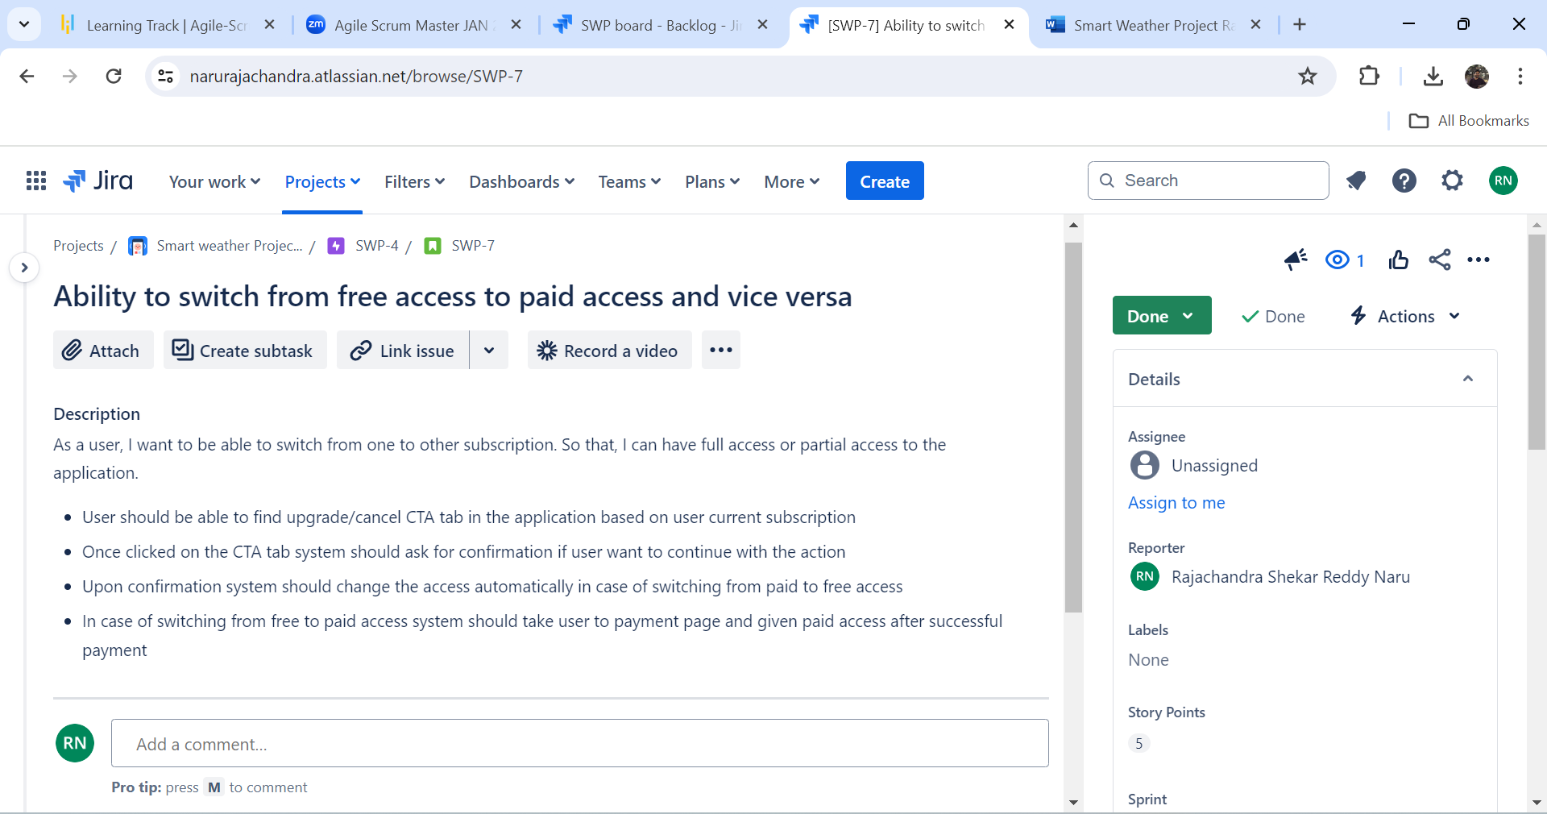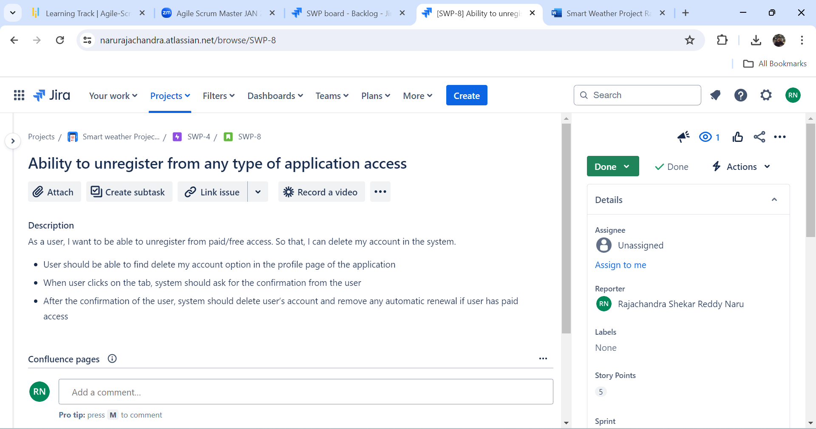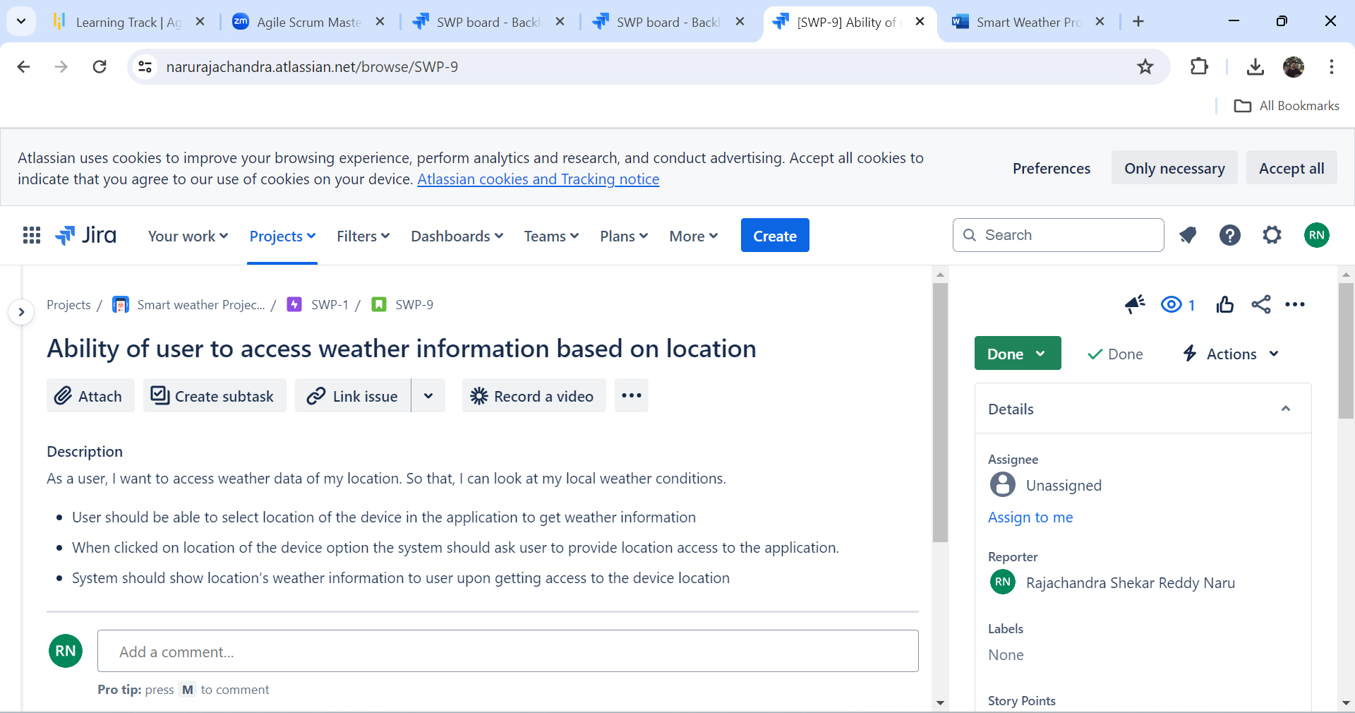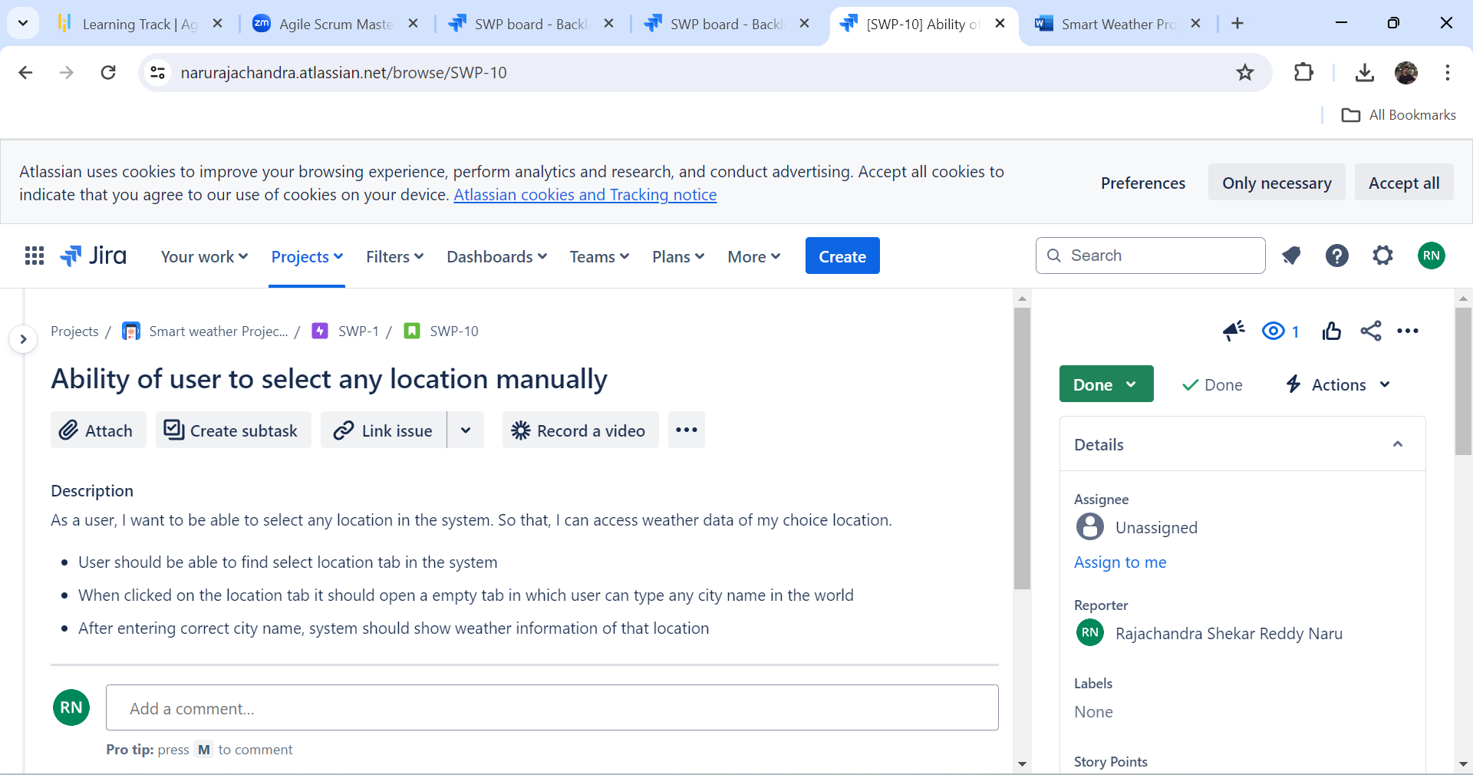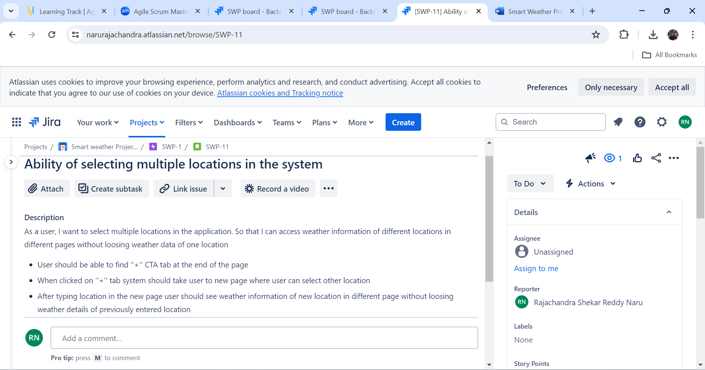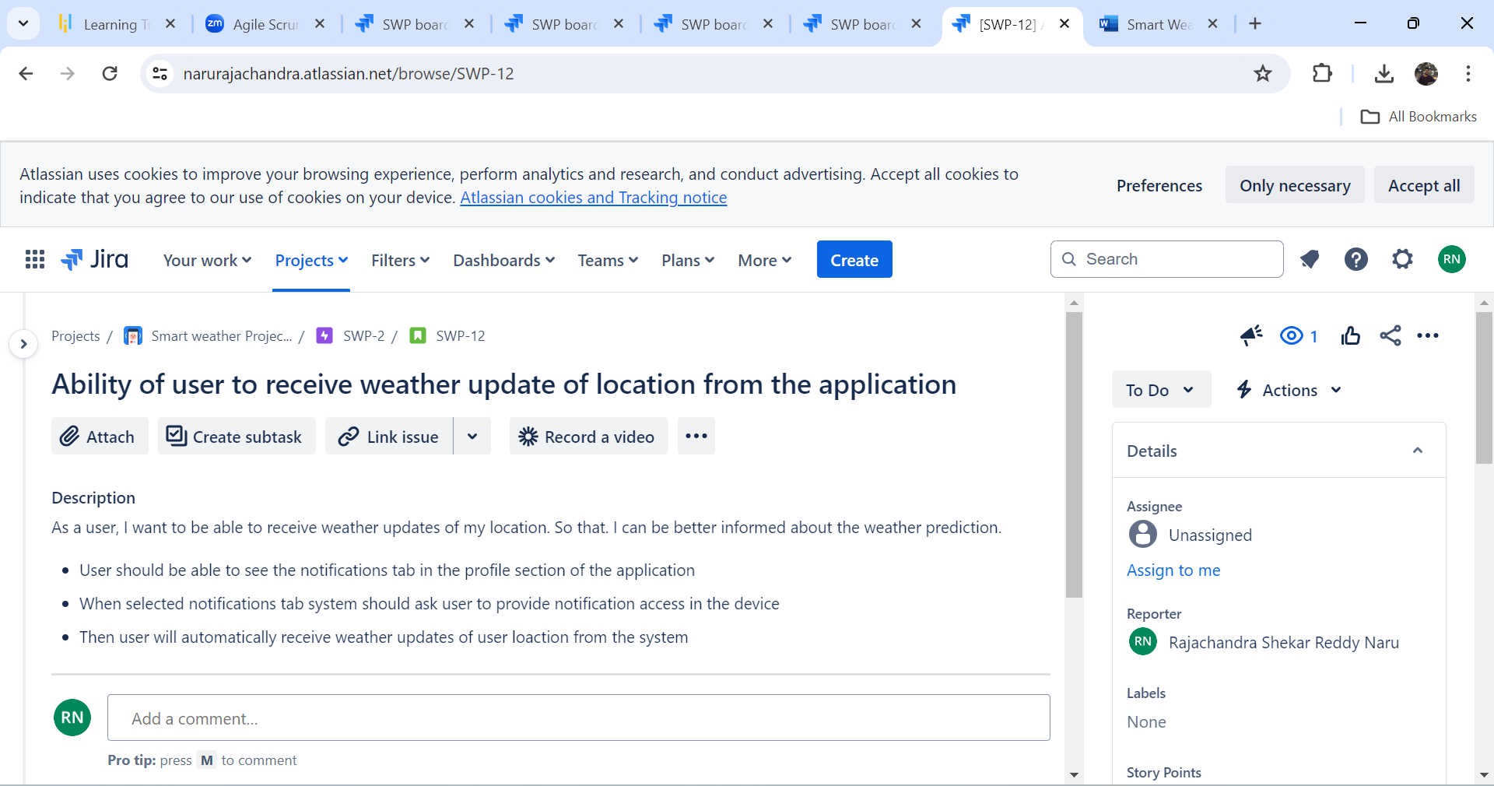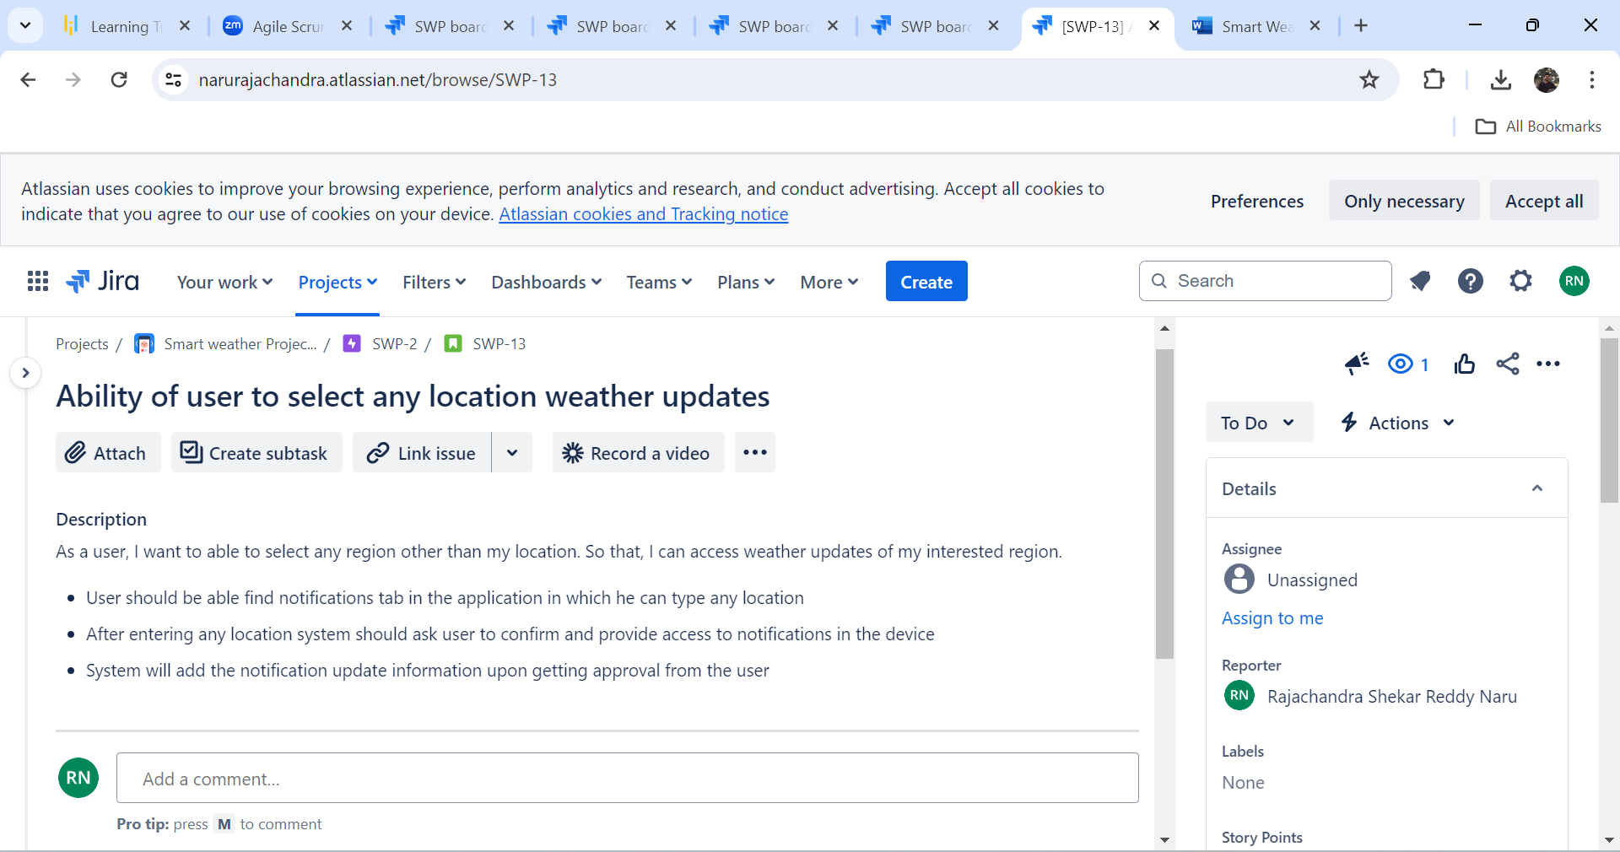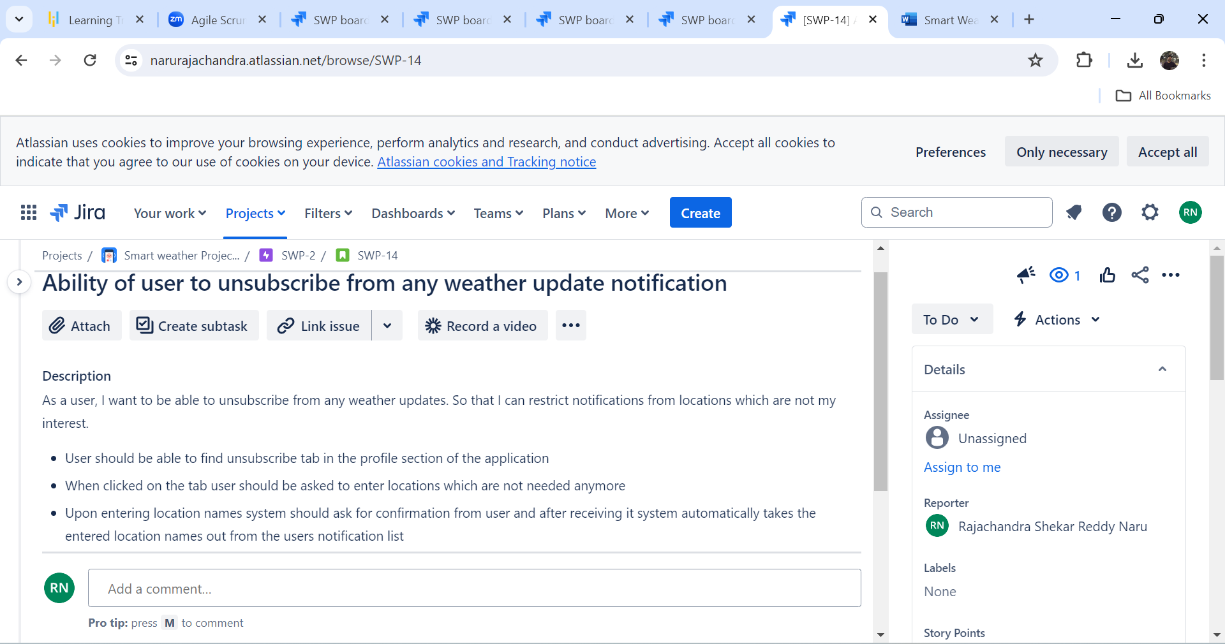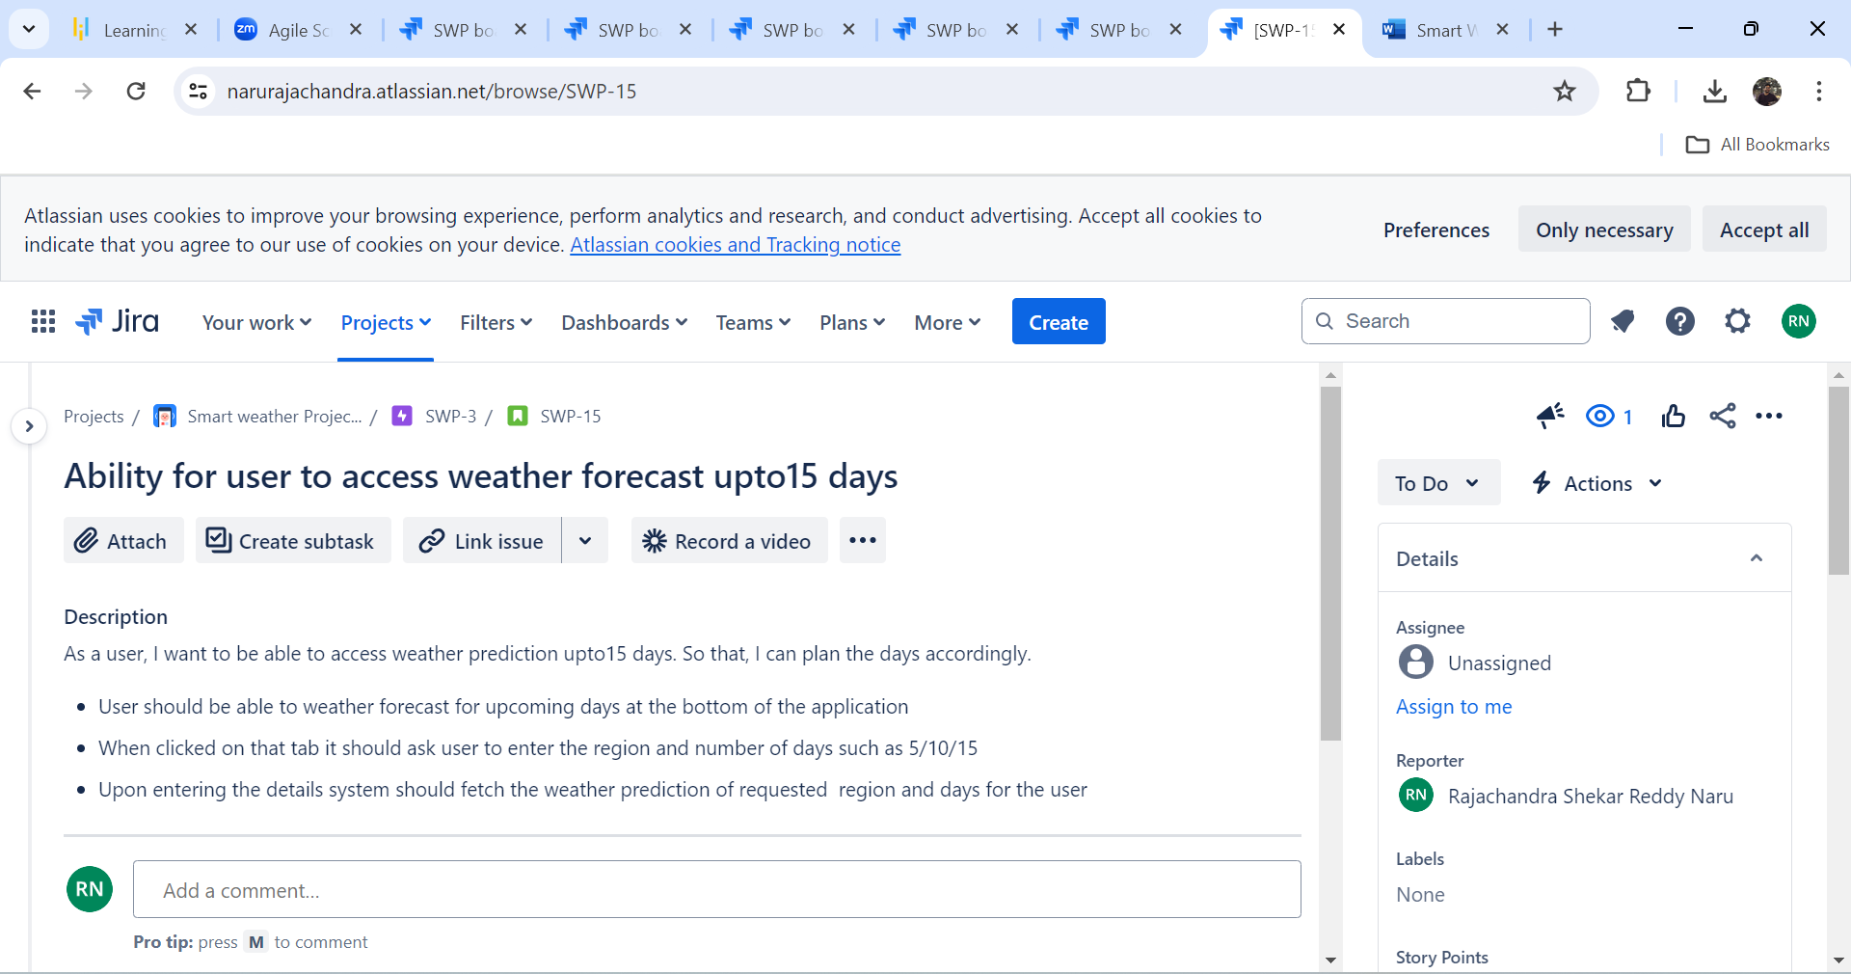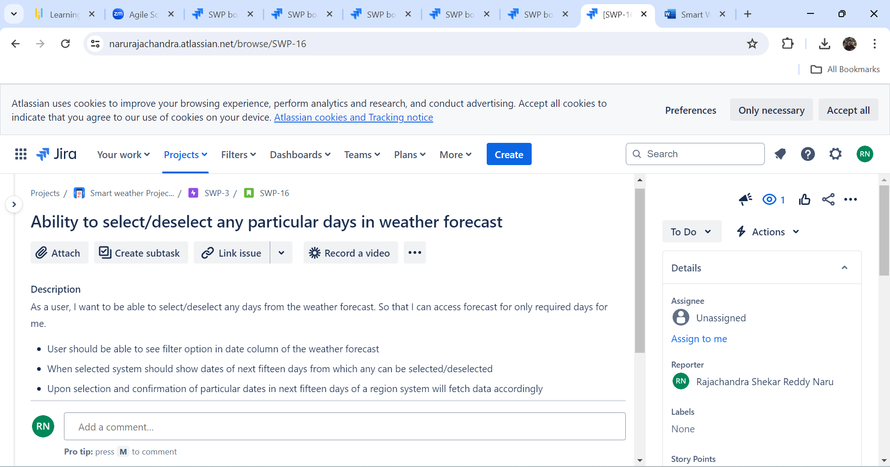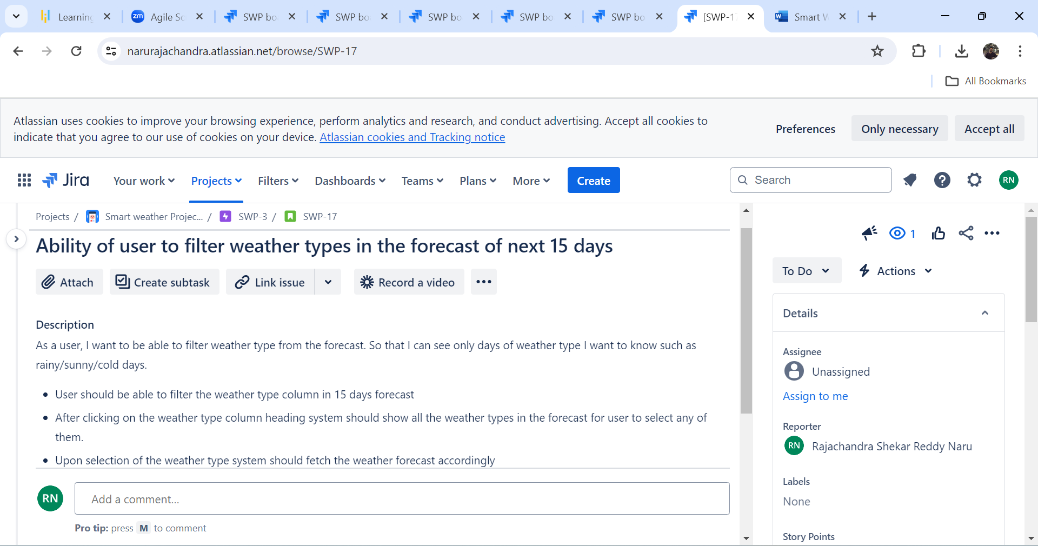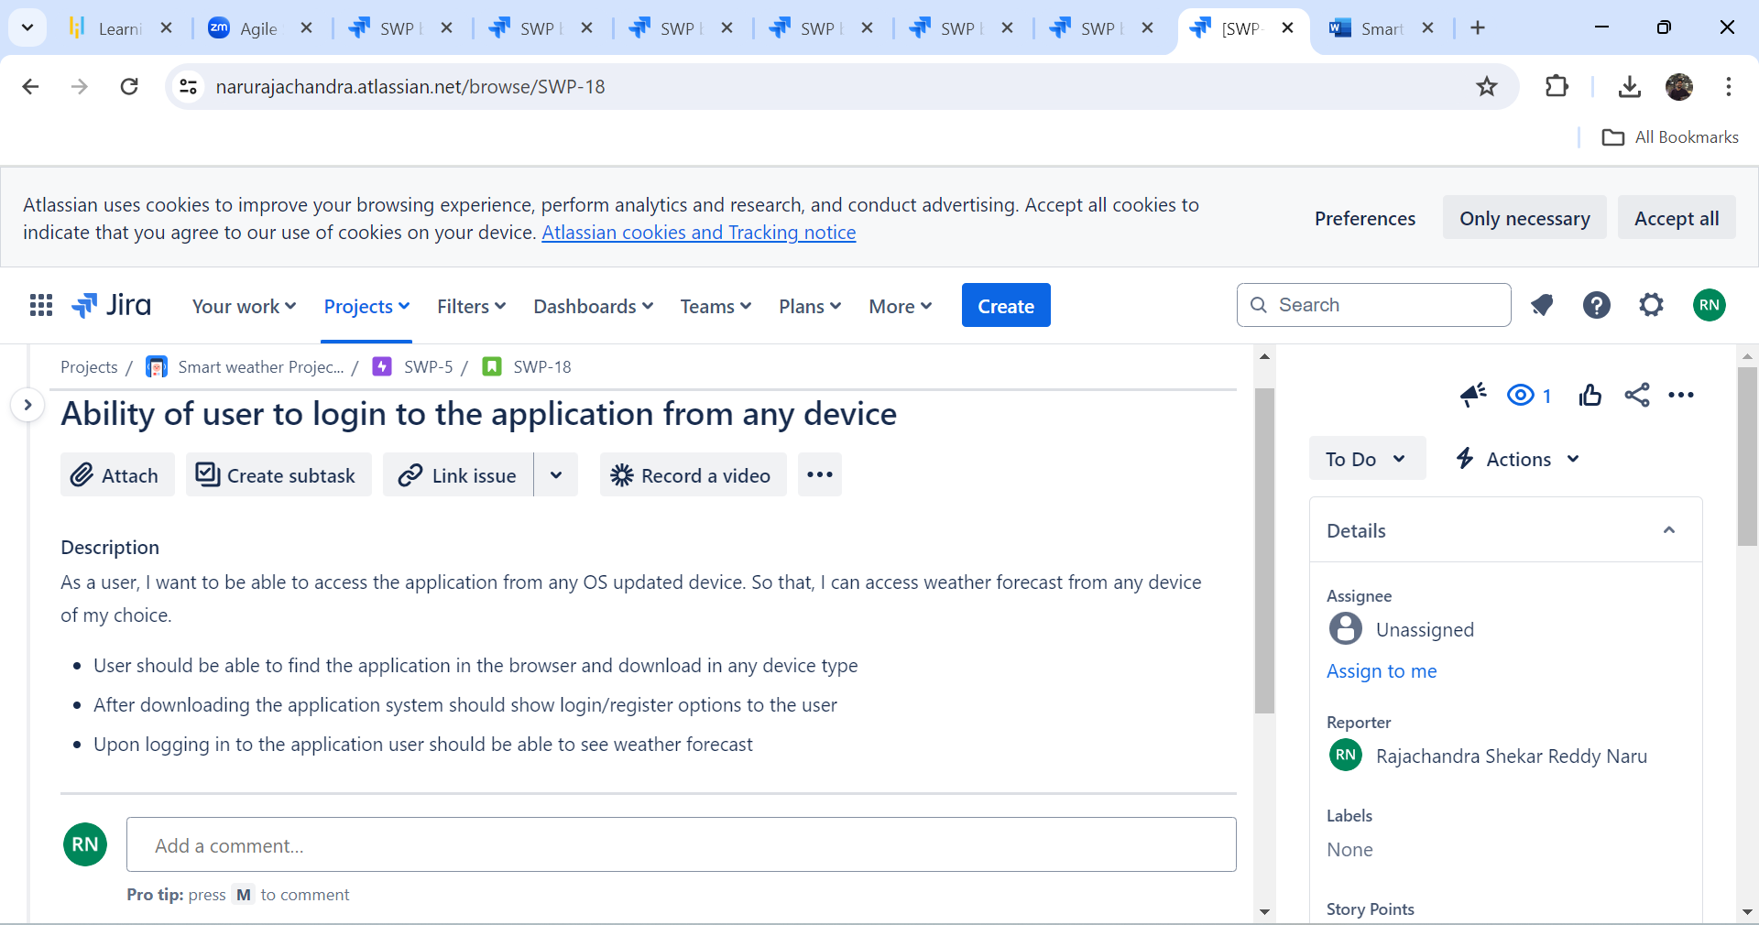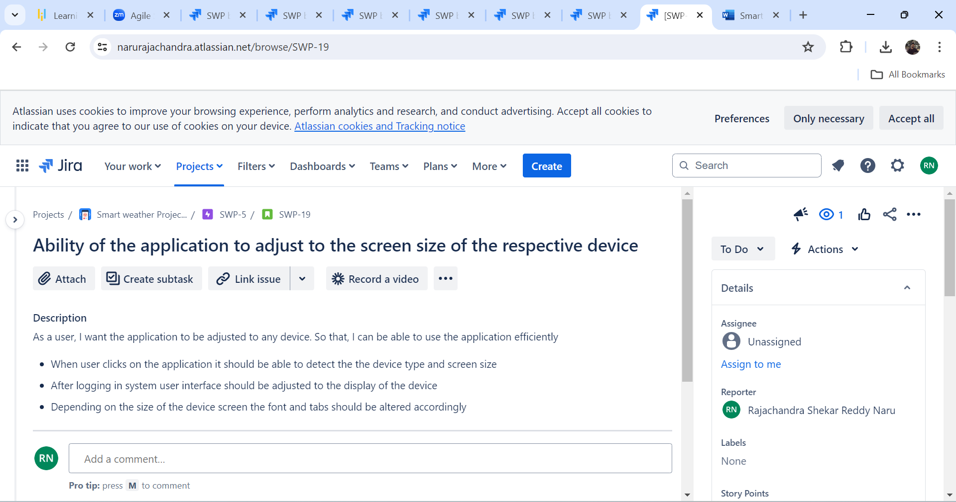

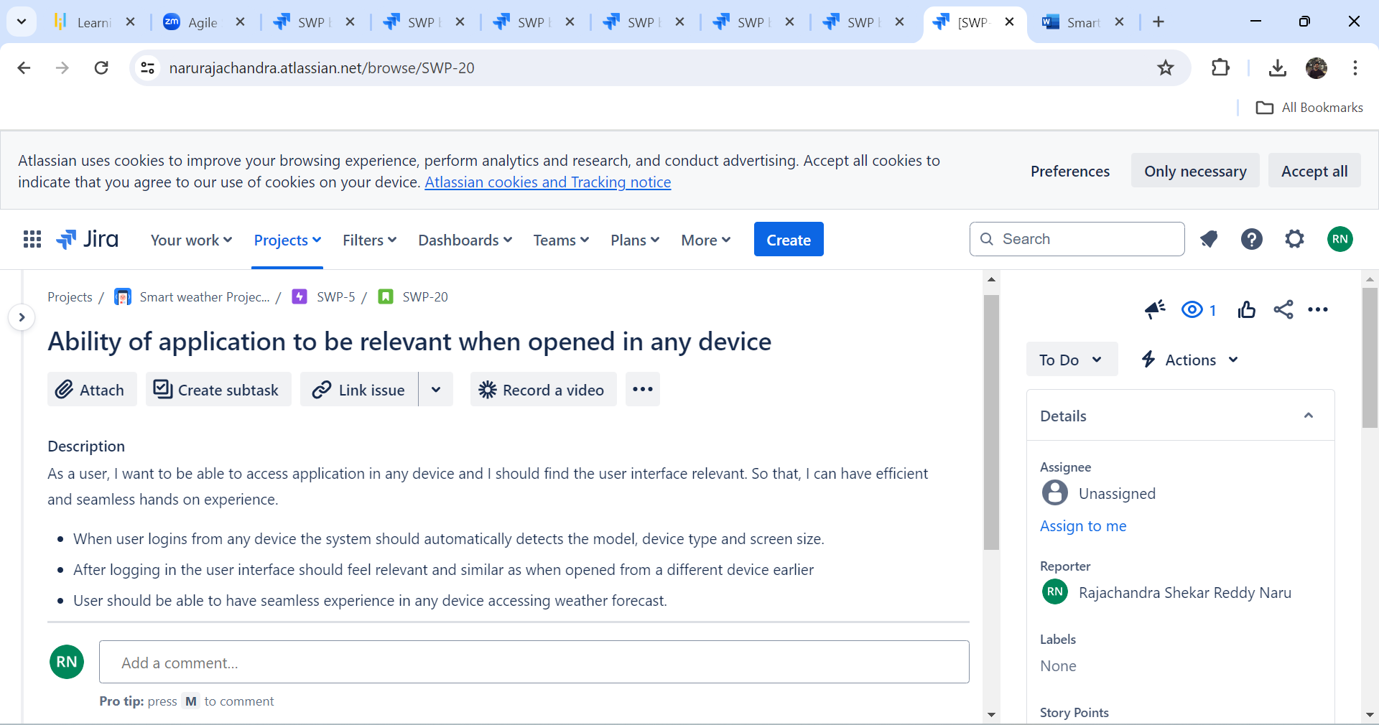

1. **BACKLOG:**

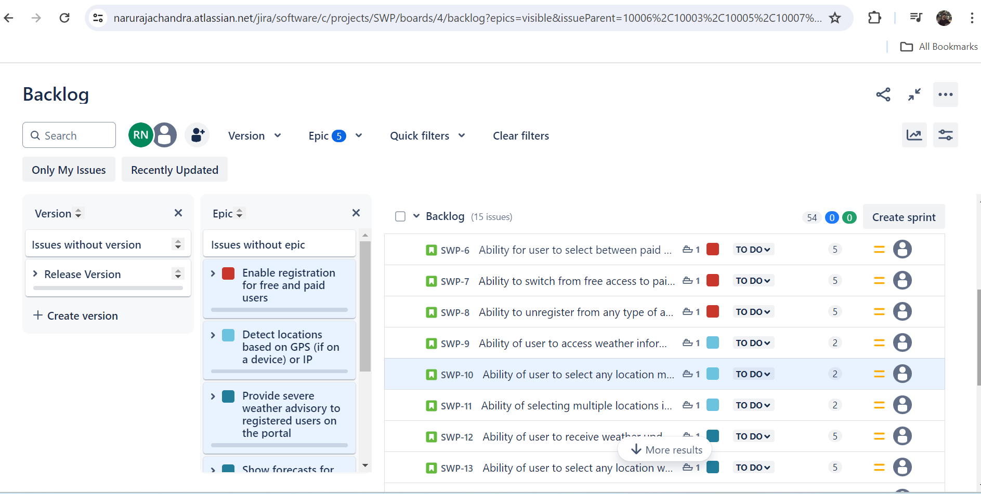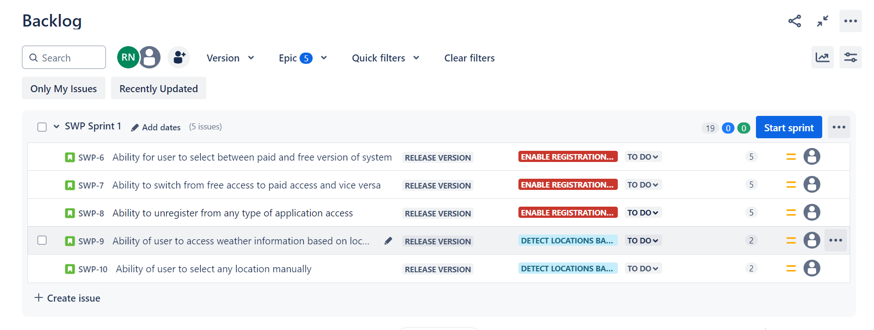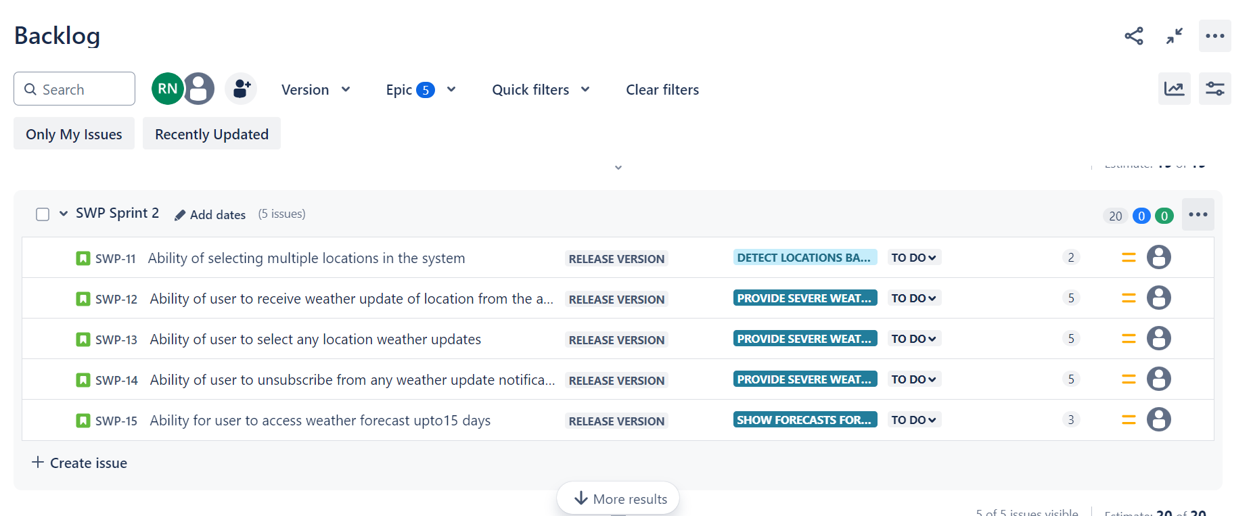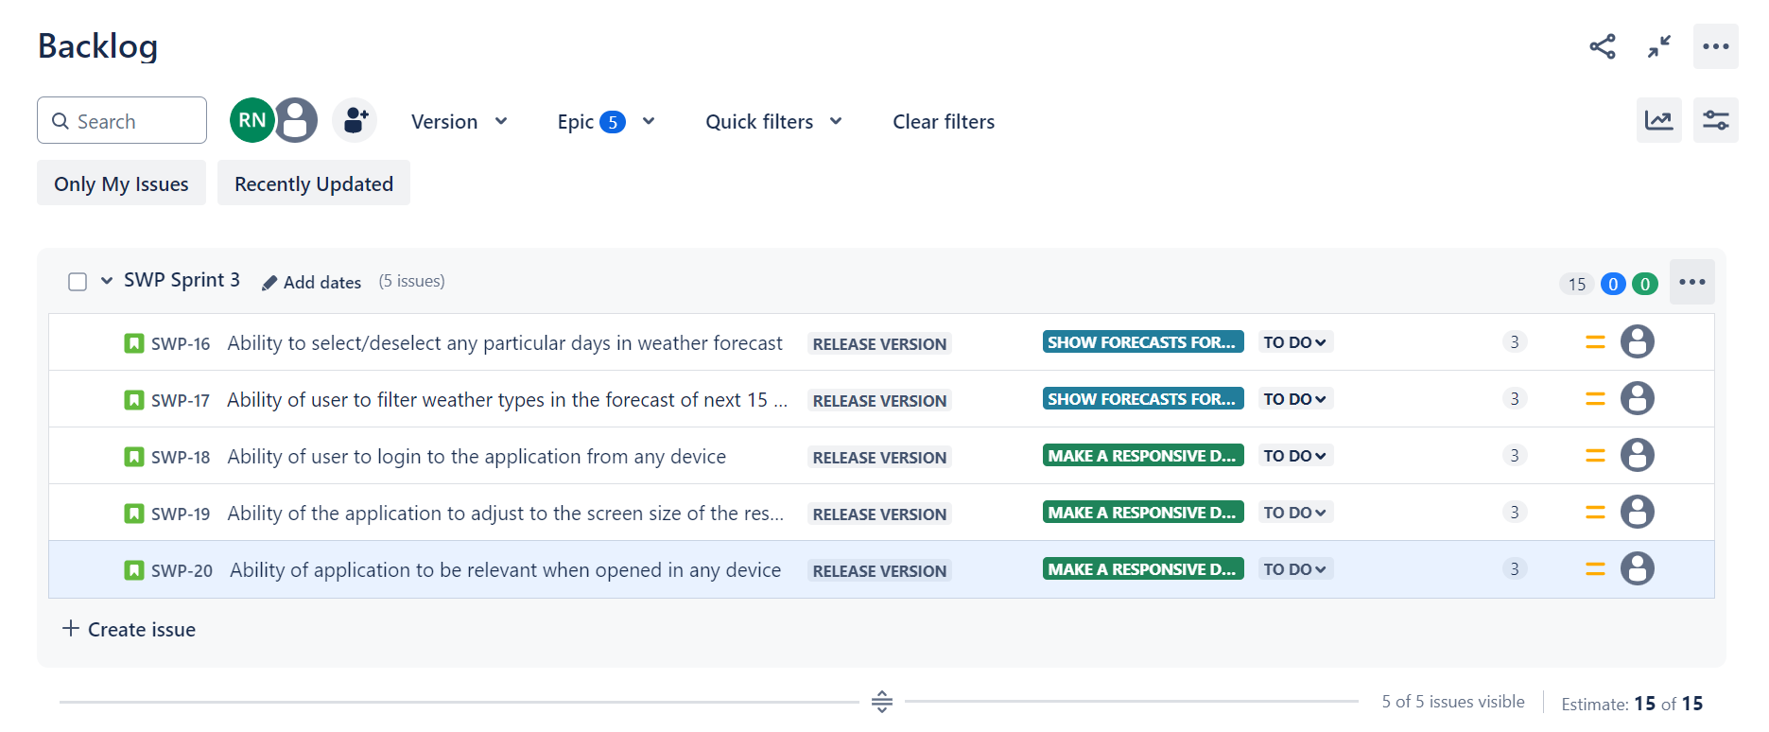

1. **SPRINT:**

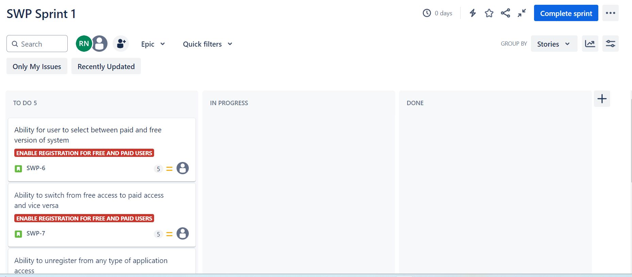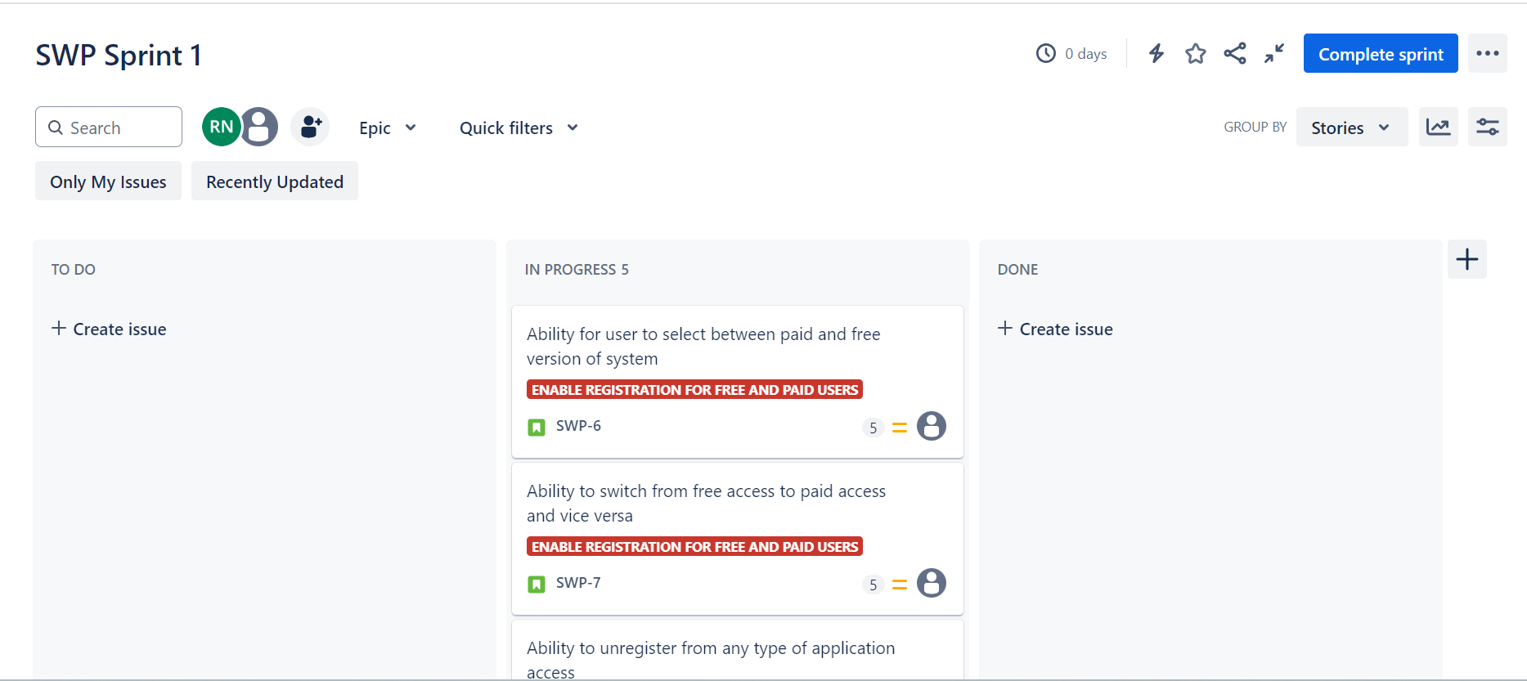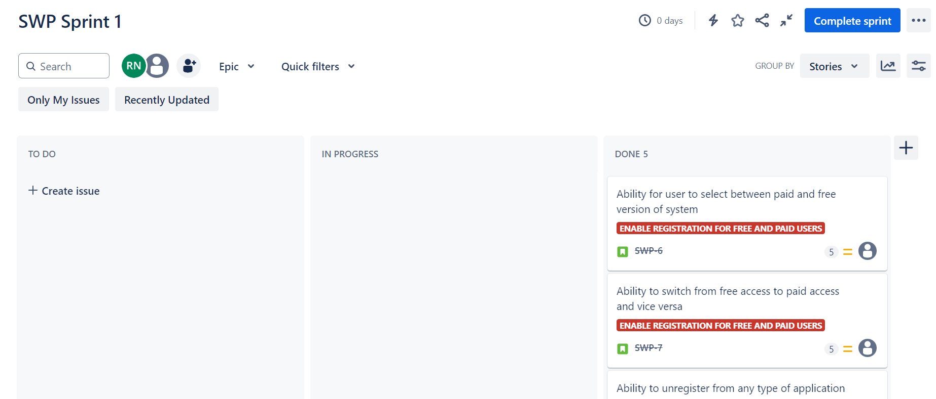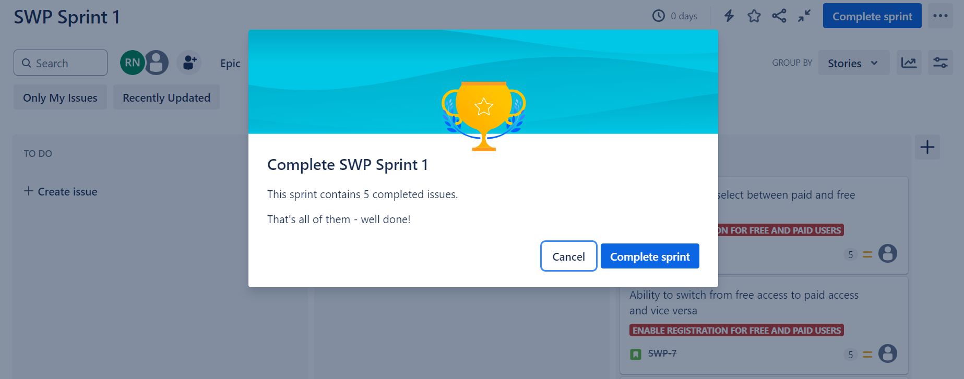

1. **REPORTS:**

